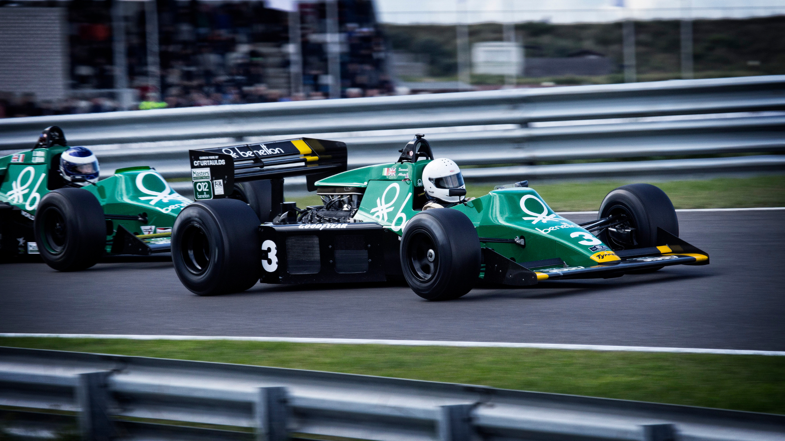

Photo credit: Canva

F1 Racing Wins

By: Leticia Rinaldini, [Morgan Prukop](mailto:mprukop@stedwards.edu), Nayma Kim

Being an Austin resident gives us the privilege to attend the world-renown Formula 1 races once a year. Our Circuit of Americas track has been used every year since 2012 (excluding 2020 due to the pandemic of course). This global race has become a symbol of status and sometimes even wealth since it made its debut in 1950. This would make sense considering it has a yearly revenue in the billions of dollars. Our group wanted to find out what it takes to win this high stakes race, and what could potentially set you back, by creating a model to predict success in the races as well as analyzing all of the relationships between the factors and the driver’s final position in the race.

Our group utilized a dataset found on [Kaggle](https://www.kaggle.com/datasets/cjgdev/formula-1-race-data-19502017?select=circuits.csv) consisting of 15.3MB of data divided into 13 separate CSV files. The data consisted of information from races starting in 1950 all the way through the 2017 season. The data included information on the driver, driver standing, constructor, constructor standing, constructor results, pitstops, lap times, qualifying races, circuits, seasons and results. Upon further investigation of our data, we decided to drop the file consisting of pitstop information due to the fact that pitstops weren’t and aren’t always used in Formula 1 or its seasons.

We began our process by combining all 12 of the CSV files we decided to use, into one large dataset. Once we had accomplished this we went ahead and dropped missing values, label encoded our data, and transformed all of the times into milliseconds to make them unified and useful. The overwhelming number of races, drivers, laps, and information we had to wade through and sort was a large portion of this project.

The cleaning process also allowed us to inspect the columns and data further. We realized that we had some technical terms we were unfamiliar with, as well as history and format of the races. In order to expand our understanding we did an abundance of outside research to become F1 experts.

First we looked at the history and format of the race. Formula 1 is a series of races taking place at various FIA approved circuits all over the world. Each season consists of 17-22 races, each lasting an average of two hours and a distance of 305km (190 miles). Though each circuit is only a few miles long, drivers have a designated number of laps they must complete in order to reach the 305km it takes to complete the race. Prior to the actual race beginning, there is a qualifying session generally taking place the day before the actual race. These qualifying sessions consist of three rounds, with the five slowest vehicles being eliminated each round. According to fans and F1 connoisseurs, these qualifying events are the most exciting portion of the whole race. The reason is that how you place in these rounds determines where you begin the actual race on the grid (find definition for grid below). The qualifying rounds can make or break a driver’s chances and they always keep everyone on the edge of their seats! To win the race is simple, you must simply finish FIRST. Only the first 10 drivers to complete the race are awarded any points at all with the first place receiving 25 points and 10th place receiving only one point. At the end of each season all of a driver's points are added up to determine their rank and overall place for the season.

Definitions

* **Circuit:** A circuit is a track or loop of road that must be approved by the FIA. Circuits are only a few miles long in total and require several laps (average of 78 laps) to reach the target mileage.
* **Grid:** the position where the driver will begin their race. Position is determined by the qualifying session prior to the race. Racers that begin in the very back have a disadvantage starting several seconds behind those in the front.
* **Constructor:** AKA team. The constructor is the owner of the engine and financially backs the drivers they choose. Some commonly known and successful constructors are Ferrari, Mercedes, and McLaren.

Once we had gained some formula one knowledge, and effectively cleaned and encoded our data, we jumped into our analysis. Before designing our model, we wanted to see how each of the relevant factors impacted the average final position. We first looked at the rank and the average final position. This seemed like the most obvious to have a correlation, since the rankings are made using past performance. We found that there were some outliers, as some driver’s did not have rankings yet due to it being their first season, and also that number of drivers has changed over the years a few times, though it’s most commonly 22 drivers. We also found that for drivers with ranks between 1-6 they were likely to place in 5th place or better. Driver’s ranked 7th or higher were far less likely to place well in the race.

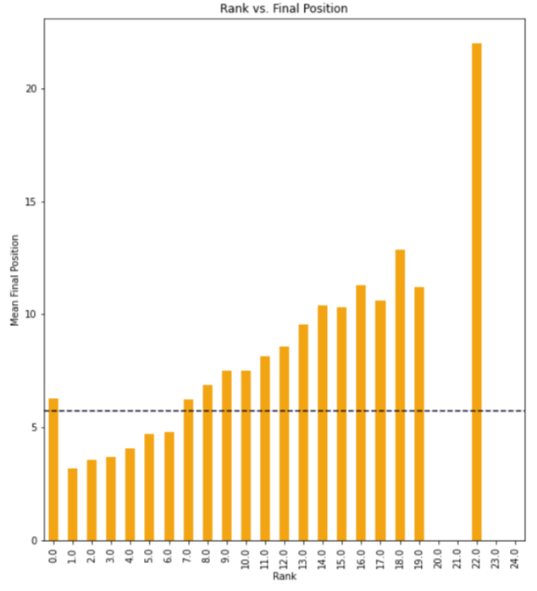

Figure 1

Next, we looked at the grid position. As we mentioned earlier, the qualifying races determine your starting position on the grid. It seemed to us that this would be a big factor in race success, as the drivers starting in the back positions lack the head start of those ahead of them. We found again that our data had some outliers, making it look as if those on place 24 on the grid had an average final position of better than 6th place. The reason it appears that way is because we had very few seasons that had 24 drivers and a 24th grid place. The seasons with missing data for the grid also skewed this. However, we were still able to see that overall, drivers starting in the first 5 positions did significantly better than those starting behind them.

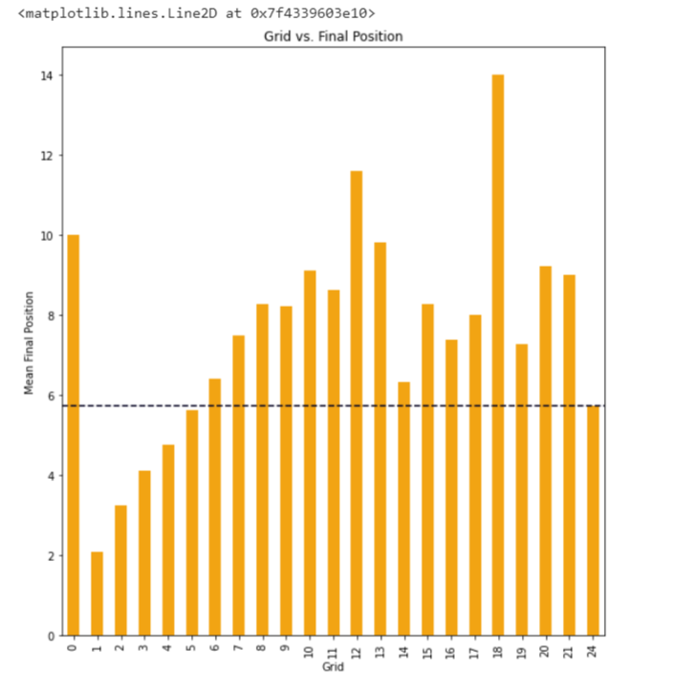

Figure 2

Our next thought was that the lap position the driver maintained throughout the race would have a great impact. We decided to build a bar graph to view the relationship between the average final position and its relationship to the lap position throughout each race. We found that drivers staying in positions 1-5 for the majority of the race would simply place in 1-5. We also found that drivers in lap positions 17-21 generally made it into the lap group ahead of them, lap positions 13-17, more than any of the other positions moved. We attributed this to the last 5 drivers feeling pressure to catch up in order to place and not be last. You can view our graph analyzing this relationship below.

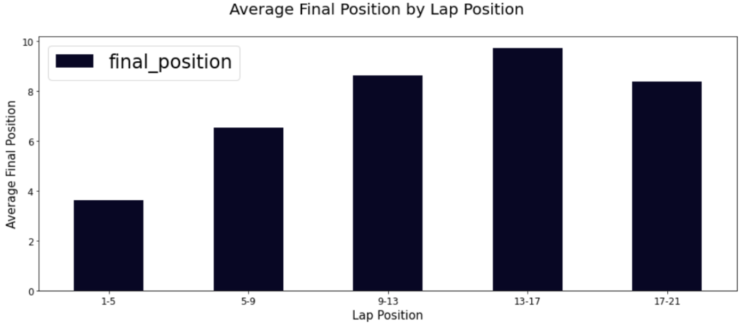

Figure 3

Based on our research, we found that F1 drivers, teams and cars are funded and the cars built by their constructor teams. Our data provided detailed information on the constructors and their scores. The best constructors tend to have the best drivers and cars as well as the most funds. This leads to them maintaining successful outcomes in the races year after year. When analyzing the relationship between the constructors and their final positions, we found that a few constructors do better than the average. The top constructors were Brawn, Ferrari, McLaren, Mercedes, and Red Bull.

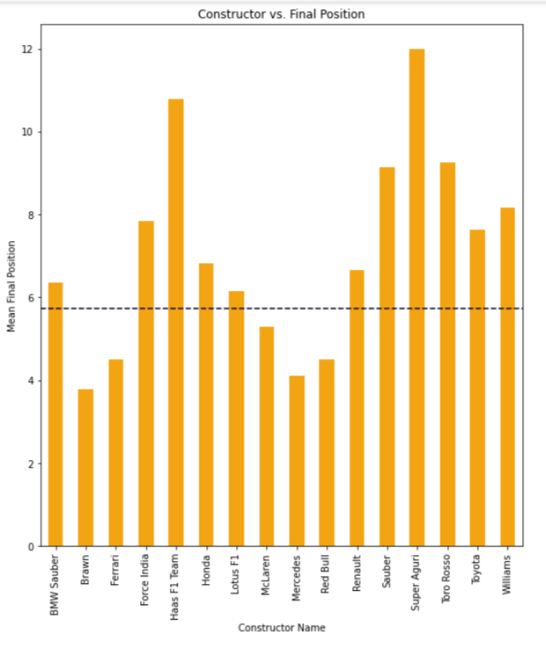

Figure 4

Once we had looked at all of the valuable factors provided in the data, we decided to engineer our own to get more of an in-depth understanding. Firstly, using what we had in the data already we found that driver nationality also plays a part in winning the race (figure 5). British and Finnish drivers have had the most success overall in the years spanning our data. Upon further investigation of this, we found that Britain is home to the second highest number of F1 sponsors globally with nearly 21% of the companies partnering with Formula 1 being based there. Finland also has 20 circuits in its small country compared to less in much larger countries. This shows how Finland values the sport and it is a priority in their culture. Looking at how the driver nationality made such an impact led us to create a new variable labeled, is_home, to find out whether a driver competing in their home country has more success than foreign drivers. We observed that there is in fact an advantage to driver’s driving in their home countries as you can see in figure 6 below. This may be due to the fact that driver’s feel more of a need to succeed and a sense of pride when competing on their home turf.

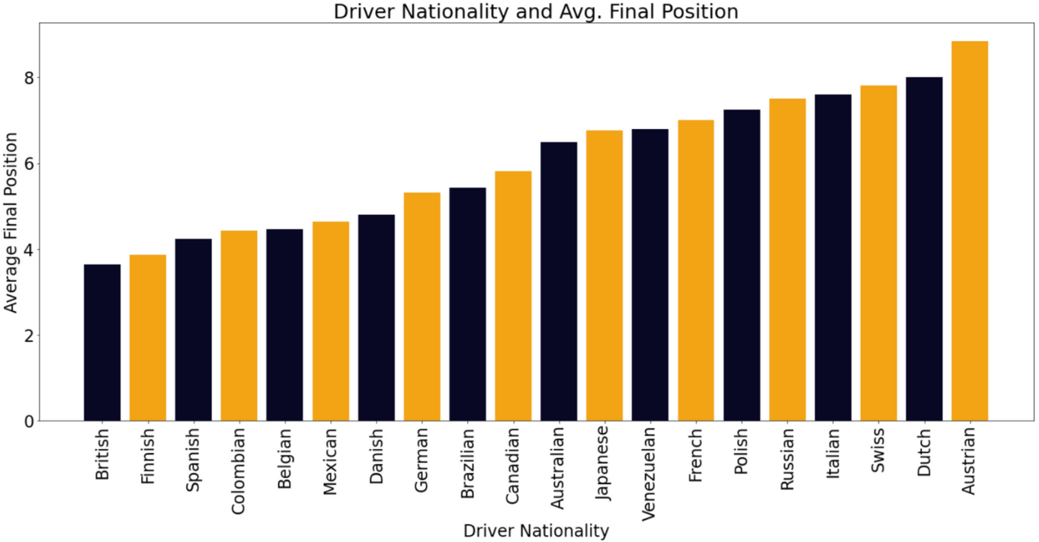

Figure 5

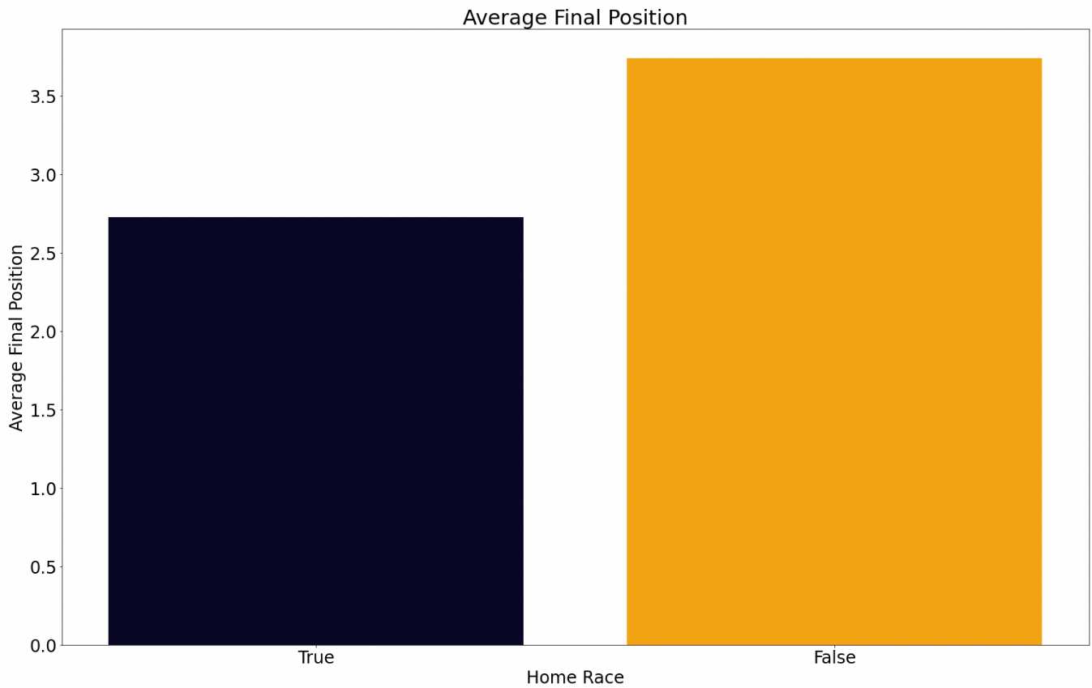

Figure 6

Finally, we began to build our model. We started the process by taking the columns we had already found some relationship with as well as a few others we thought may be useful, and creating a correlation matrix out of the data. We observed that grid, rank, wins, qualifying position (which is what is used to decide the grid position) and the lap position had the highest correlation to the final position, which is what we aimed to predict.

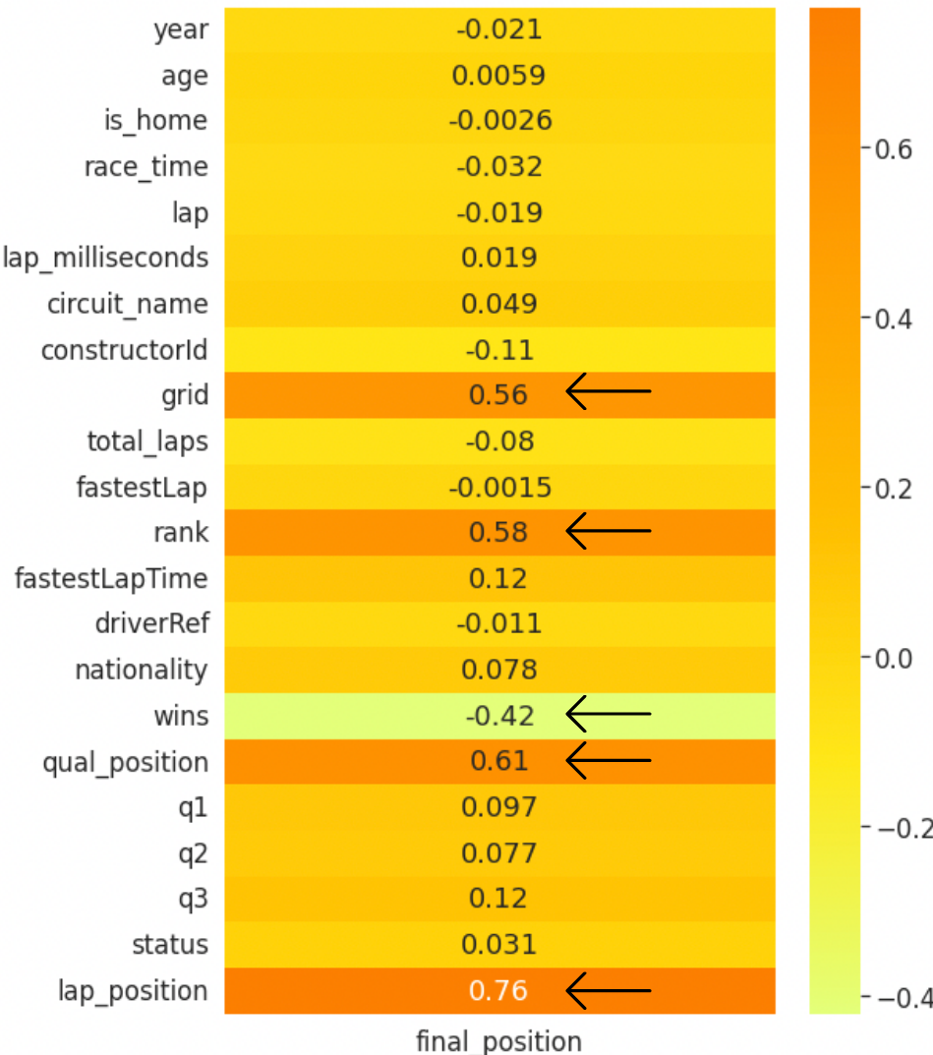

Figure 7

Our first model type was a simple linear regression model. The columns of data we utilized for this were year, age, is_home, lap milliseconds, circuit name, grid, rank, fastest lap time, fastest lap position, wins, nationality, qualifying position, q1, q2, q3, status and lap position. All of these columns in a simple linear regression model actually yielded scores that were not terrible. The R^2, or the accuracy, was 0.6765. This means that the model was accurate with its predictions about 68% of the time.

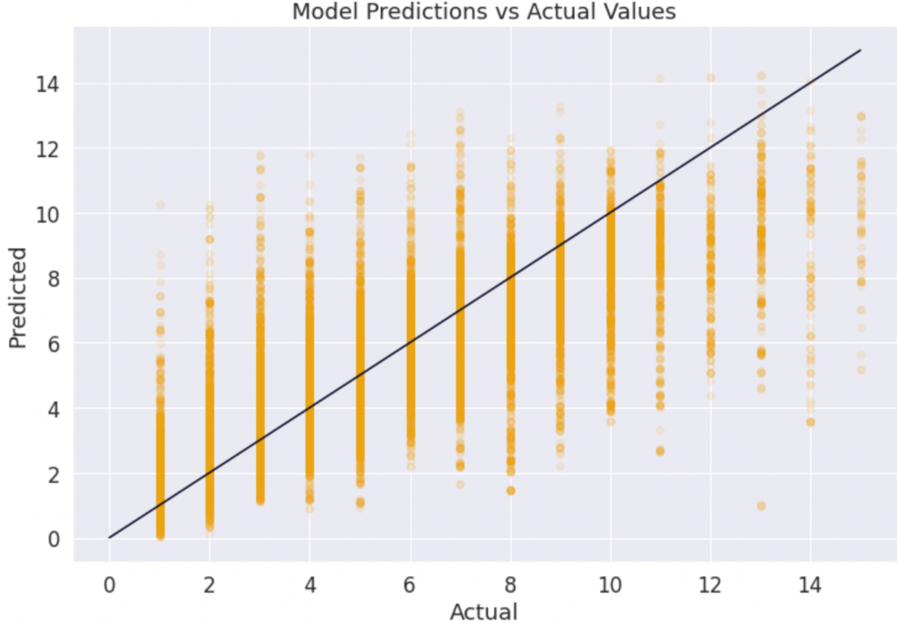

Figure 8

Once we had this base model settled, we tried a few different other models. We ran a grid search for hyperparameters on a decision tree model and tried a few different combinations of columns. After running the grid search a few times and finding the combination of columns that seemed to work best, we ran a decision tree regressor model and got a much more accurate model than with the linear regression. Using a max depth of 30, minimum samples split of 4, and a minimum samples leaf of 2, we were able to produce an accuracy score of 0.9536. Again, that means that our decision tree regression model was accurate with its predictions approximately 95% of the time. You can find more details on the various models and processes we used to get here on our [Github](https://github.com/leticiari03/F1-Racing-Wins) repository.

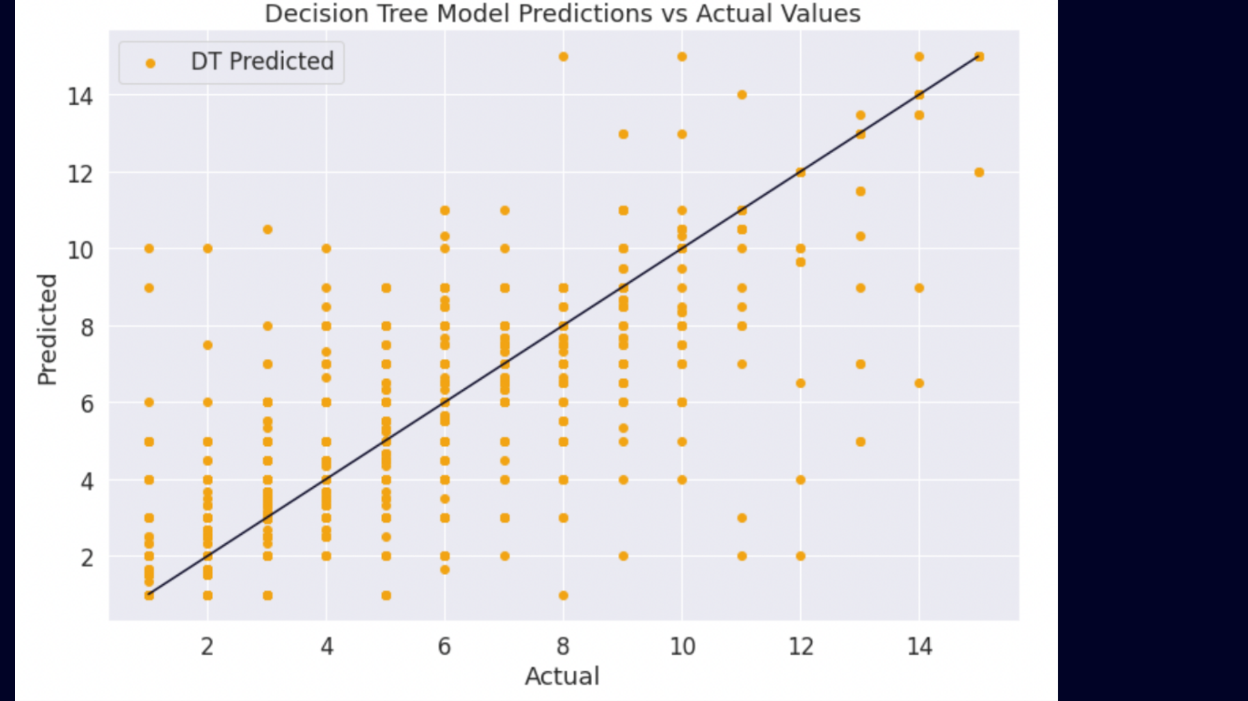

Figure 9

In conclusion, we learned a lot about Formula 1 and how it is formatted. We also learned a lot about what it takes to be successful in these races. A driver must find a dependable constructor with the funds and vehicles necessary to elevate them above other drivers and constructor teams. They must also place well in the three qualifying rounds, or else they are unfortunately likely to remain at the back of the pack where they started. Driver’s competing in their home countries will also be at an advantage to win. We found these to be the most important factors to the success of Formula 1 drivers and their constructors. We hope you found learning a bit more about Formula 1, its history, and what it takes to be a winner as much as we did.